How to upgrade

PC <-> STB

- Pull out the STB power plug.
- Connect “Computer” and “STB” using RS-232C Serial Cable.
[ ODS2000 model ]
(ex. ODS2000F, ODS2000CI, ODS2000CIV)

RS-232C Serial Cable
Type : 1:1 Cable
2 |  |  | 2
3 |  |  | 3
5 |  |  | 5
PC Serial Port |  | STB Serial Port
(Female, 9Pin) |  | (Female, 9Pin)

[ other models ]
(ex. ODS3000, ODS4000, C-box, T-box, etc)

RS-232C Serial Cable
Type : Null Modem Cable
2 |  |  | 2
3 |  |  | 3
5 |  |  | 5
PC Serial Port |  | STB Serial Port
(Female, 9Pin) |  | (Female, 9Pin)

- Run “ODSEdit” or “ODSLoader” on your Computer.
- Choose “COM port” from menu “Tool->Configuration”.
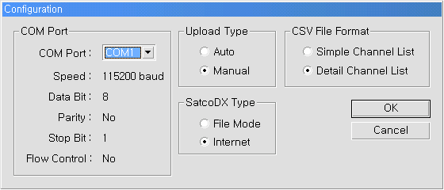
- Select “File->Download” from menu after open the file you want to download.
- Transmission will be started after plug on the STB.
- When there is a message “End” on the STB, it means upgrade is successfully finished. If there is a message “Fail” on the STB, it means upgrade is fail.

※ ODSEdit or ODSLoader can download at Download Utility on Opentech Homepage (http://www.opentech.co.kr).

